WELLNESS

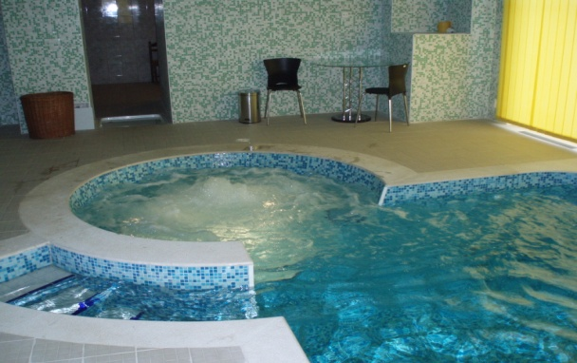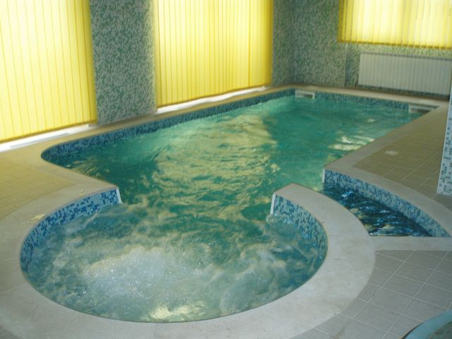

Refrash and relaxed your self with wellness in complex of hotel.

Like our guests You have special offer price tu use wellness.

Use recreation swimingpool, jacuzzi with under

wather massage and finland sauna..

Also we can offer You a medicin massage from

doctor who is a physical therapist..

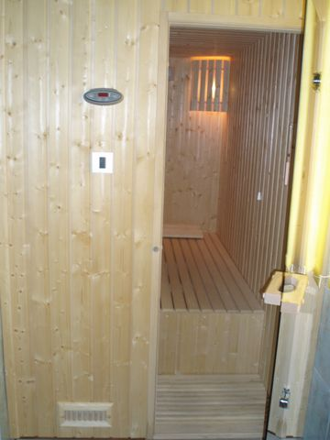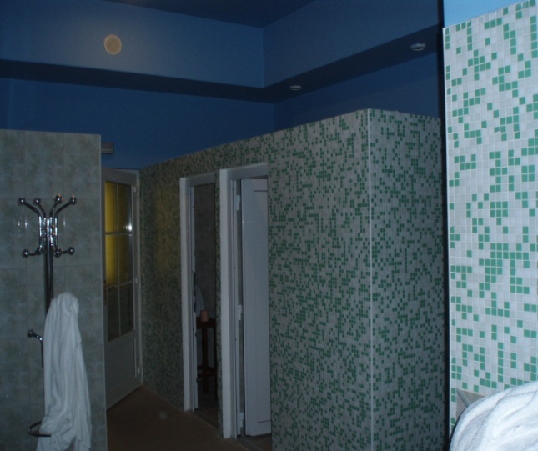

• Pool area is equipped with showers

More information on web site: [**www.hotel-mirni-kutak.hr**](http://www.hotel-mirni-kutak.hr)